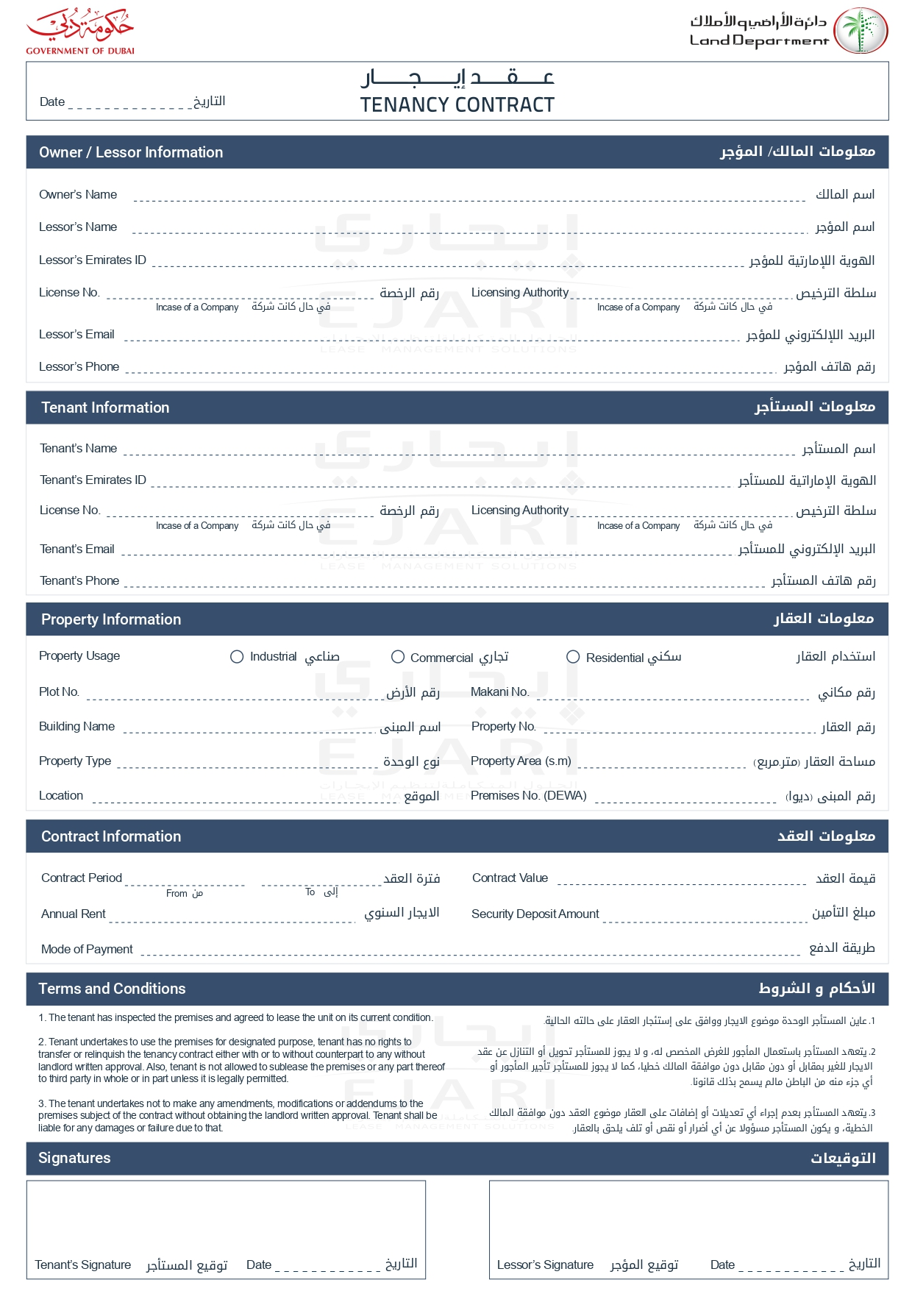

2025-04-09

John Smith

John Smith

john.smith@example.com

+971501234567

Emily Brown

emily.b@example.com

+971505678901

✓

G-102

Green Villa

1,300.00

GV001

2,000.00 EGP

2025-08-09

2025-04-09

100.00 EGP

2,000.00 EGP

Weekly

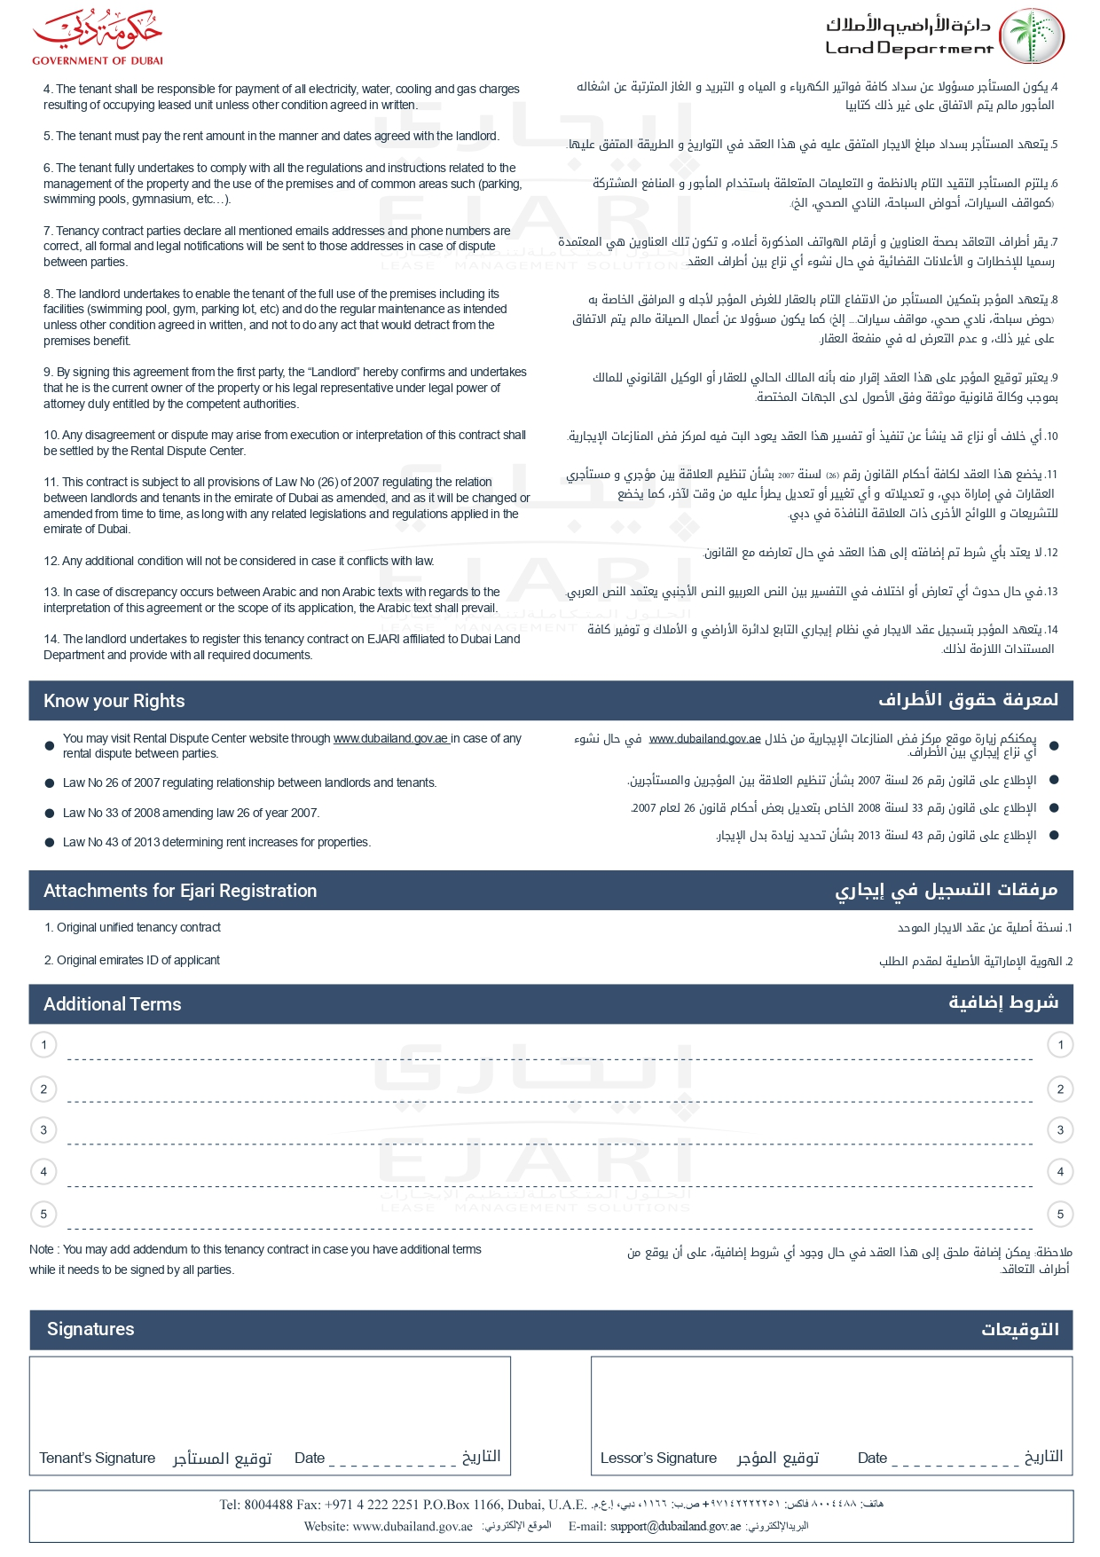

string terms 1